Rethinking Grid Integration of a Massive Renewable Power Expansion to Achieve Carbon Neutrality in China and Beyond

A Research Brief for Non-Specialists

State Key Laboratory of Advanced Electromagnetic Engineering and Technology, School of Electrical and Electronic Engineering, Huazhong University of Science and Technology, Wuhan, China

Harvard-China Project on Energy, Economy and Environment, John A. Paulson School of Engineering and Applied Sciences, Harvard University, Cambridge, MA, USA

Department of Electrical Engineering, Tsinghua University, Beijing, China

October 2021

This Research Brief is based on the findings of a comprehensive new analysis of the topic:

- Xinyu Chen, Yaxing Liu, Qin Wang, Jiajun Lv, Jinyu Wen, Xia Chen, Chongqing Kang, Shijie Cheng, and Michael B. McElroy, 2021, “Pathway towards Carbon-Neutral Electrical Systems in China by Mid-Century with Negative CO₂ Abatement Costs Informed by High Resolution Modeling,” Joule, X, X, pp. X-X. Available at [insert Joule webpage]

The study was supported by the HUST-State Grid Future of Grid Institute, National Science Foundation of China, Harvard Global Institute, and the Energy Foundation China.

This Research Brief was sponsored by the Energy Foundation China.

In a Nutshell:

- There are many uncertainties about pathways to mid-century carbon neutrality in China and other major economies, but one fundamental aspect is certain: it will require massive expansions of wind and solar power to displace coal- and gas-fired power
- Such expansion of wind and solar power generation in China is highly feasible in geophysical, technical, and economic terms. Posing a greater challenge, however, will be its grid integration because of the inherent variability of renewable outputs compared to those of thermal power as well as the distance of many renewable source regions in China’s north and west from centers of electricity demand along its coast.
- Planning cost-effective renewable grid integration requires an analytical scope extending beyond the power system alone, to key elements of the rest of the energy system that will affect the timing and flexibility of future electricity demand. These include electrified transportation and “power-to-gas” production of “green” hydrogen.
- Strategic deployment of expanded renewables, ultra-high-voltage transmission and national grid interconnection, electricity storage, green hydrogen production, and electric vehicle fleets could abate 80% of power sector carbon emissions in 2050 at a savings of US$52/ton compared to a strategy based on conventional assumptions
- Significantly driving the cost savings is the increasing feasibility of offshore wind power, portending a momentous shift in China’s national transmission structure from the conventional “West-to-East” paradigm of the present to a “Periphery-to-the-Center” one in China’s decarbonized future
- Offshore wind matters in China not only because of the size of its potential but also its proximity to the largest electric demand (load) centers on the country’s coast, freeing onshore wind power generated mainly in the interior north and solar power generated throughout the rest of the country to serve more proximal loads throughout China
- Optimized addition of electricity storage and comparatively flexible power loads of electric vehicles and green hydrogen production will help to facilitate and lower the costs of grid integration of massive renewable expansion
- Optimized interconnection of power grids on a national rather than provincial basis will sharply reduce investments (e.g., in power storage) needed for power balancing to maintain grid stability, thereby also reducing the costs of carbon abatement.
- Adopting slow charging of electric vehicles instead of fast charging (which results in spikes in power demand) similarly reduces investments required for power balancing and also reduces costs of decarbonization.
- Using even costly carbon capture and storage to mitigate the 20% of carbon emissions remaining after the above strategies in 2050 could achieve a carbon-neutral power sector at less overall cost than a “business-as-usual” pathway using only thermal power and no carbon constraints at all
- The growing feasibility of offshore wind may similarly combine with storage technologies, new forms of electricity demand, and strategic transmission interconnection to reduce the costs of achieving carbon neutrality in other major economies including that of the U.S.
The Central Role of Wind and Solar Power in Achieving Carbon Neutrality

The pathway to mid-century carbon neutrality in any major economy is enormously complex and uncertain, in part because so much can change, in ways we can only roughly project over the several decades until 2050. A few important features of a decarbonized energy economy, however, are widely agreed upon. One of the most important is that renewable power generation is certain to take on a paramount role in our future power systems. Electricity itself is too convenient and irreplaceable for modern life and decarbonized fossil fuel-fired “thermal” power—using carbon capture and sequestration—is certain to be costlier than renewables in most circumstances.

A reason this cost-effectiveness projection is widely agreed upon results from perhaps the biggest accomplishment of global clean energy efforts to date: technological advances in both solar and onshore wind power generation that are steadily driving their costs below those of even coal-fired generation, the cheapest traditional power source. This looks increasingly likely also for offshore wind, albeit over a somewhat longer term, driven by investments and advances in Europe over the last decade and China more recently. The expanded sources of wind and solar power will complement slower-growing capacities of other non-carbon power sources including hydropower, which is cost-competitive but faces resource and other expansion constraints, and nuclear power generation, which is rarely cost-competitive.

The study summarized in this Research Brief (Chen et al. 2021) assesses the strategies required to accommodate a massive expansion of renewable power in China to cost-effectively meet its goal of carbon neutrality before 2060. To achieve economy-wide carbon neutrality by that year, including harder-to-abate sectors such as heavy industries and aviation, China’s power system will likely have to be carbon neutral by 2050, the target year for this analysis. The study’s lessons are potentially applicable to similar energy transitions that will be required in other major emitting nations to meet their own carbon neutrality targets in 2050 or earlier.

The Cost-Competitiveness of Wind and Solar Power Generation

The analysis begins by evaluating the cost-competitiveness of wind and solar power generation leading up to and including 2050, without yet considering its grid integration. Resource potentials and projected generation productivity (“capacity factors”) of solar photovoltaic (PV) and both onshore and offshore wind power generation are quantified based on hourly meteorological data from NASA; availability of land accounting for altitude, slope, and existing land uses; and ocean availability accounting for sea depths, harbors, shipping routes, and protected zones. Combining these factors with current and projected investment and operational costs yields benchmark Levelized Costs of Electricity (LCOEs) for the three subject renewable source types by province, for 2030, 2040, and 2050. These are compared to the LCOEs of large coal-fired units in Figure 1. Note that variations in the LCOEs of coal-fired generation result mainly from avoided costs of coal transportation to power plants in major coal-producing provinces.

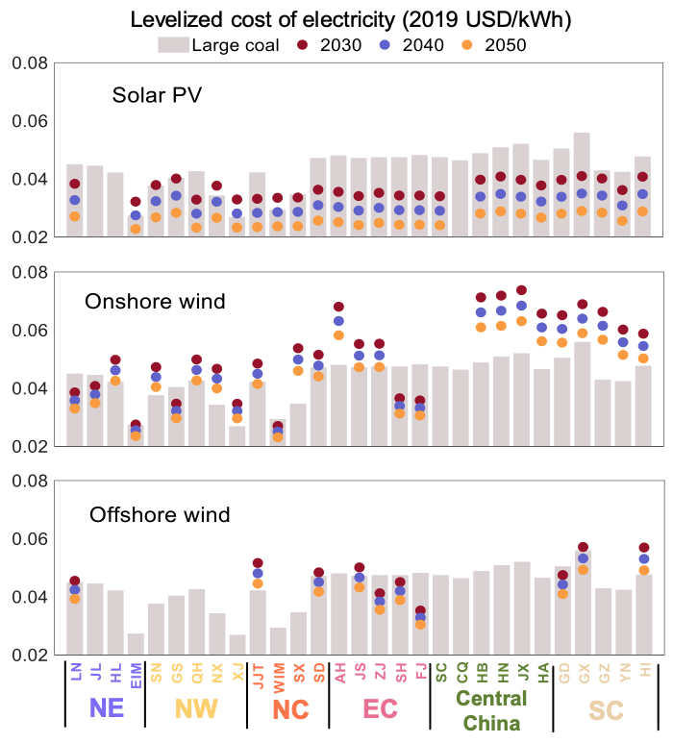

Figure 1
Levelized Costs of Electricity for Renewable vs. Coal-Fired Generation in 2030-2050, in 2019 US$/kWh

This initial evaluation reveals that solar PV power generation will be cost-competitive with coal in nearly all provinces by 2030 and its advantages will only grow with time. Onshore wind will be cost-competitive mainly across northern provinces, but not in southern and central regions because of comparatively poor wind conditions. The economic evaluation of offshore wind takes account not only of wind quality but also the distance to shore and sea depth given the need for seafloor transmission. It indicates that it too will be increasingly cost-competitive with coal power in most coastal provinces, if on a somewhat later timeframe.

Challenge of Grid Integration and Need for a Comprehensive Energy Assessment Model

Accommodating the variable output from renewable generation in comparatively inflexible power systems developed around thermal generation is the primary obstacle to power system decarbonization. This is readily evident in China today, where as much as 16% of actual available wind power nationally has been curtailed (wasted due to grid constraints) in recent years, particularly in northern wind-rich provinces, prompting the government to suspend approval of new wind farms in these provinces until curtailment can be reduced. Similar curtailments have also afflicted solar (and hydro) power production in recent years. This occurred while the renewable share of total power generated was still modest compared to the 80-90% needed to achieve carbon neutrality: around 13% was generated by wind and solar together in 2020, and 26% if hydro is also included.

The challenges of grid integration of renewable power, while critical to decarbonization, have not been adequately considered in studies to date of national pathways to carbon neutrality in China. Limited by data availability and modeling complexity, most studies consider only selective time periods (not the continuous 8760 hours of a year) and do not capture limits to operational flexibility of thermal power units. They also consider only limited transmission corridor possibilities and do not differentiate properties of AC and DC lines under different voltage levels. They do not adequately consider the effects of major new power demands including an electrified vehicle fleet and green hydrogen production. And importantly, they do not anticipate potential large-scale scaling up of offshore wind in China’s power mix.

To capture the many intricacies and tradeoffs in addressing the grid integration challenges of renewable expansion requires a unique analytical platform. It requires a high-resolution assessment model that crosses sectors and considers not only renewable resources discussed above but also hourly simulation of power system operations over a year and the characteristics of electrified transportation. It then must be able to optimize investments in renewable generation, interprovincial transmission, power storage, and green hydrogen production, all on a provincial level, and calculate the costs of resulting carbon reductions. To understand more about the model, including its imbedding of a proven fast unit commitment model to accelerate its considerable computations, interested readers are referred to the underlying publication.

Geographical Distribution of Power Generation and Transmission

[Text pending]
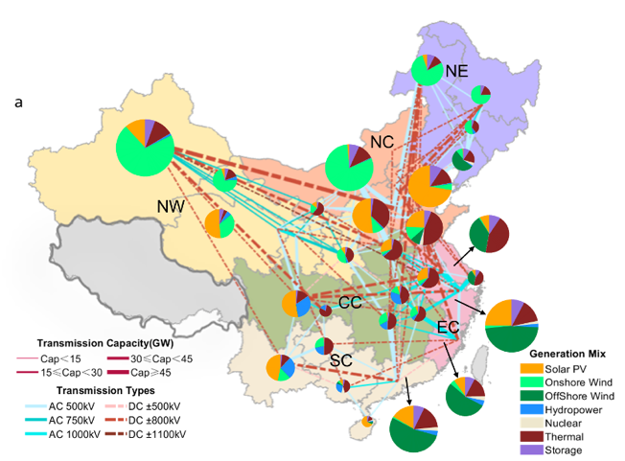

Figure 2
Geographical Distribution of Optimal Provincial Generation Mix and Interprovincial Transmission under 80% Decarbonization in 2050

Benefits of UHV Transmission Interconnection

China has constructed large-scale, ultra-high voltage transmission networks to move large amounts of electricity, often using DC lines to transmit renewable power generated in the west over long distances to load centers in the east with low line losses. The effectiveness of the existing network has been debated within China. To evaluate the benefits of greater “interconnection” of power grids across China under sharply expanding renewables, the study compares two scenarios: one relying on the limited existing interprovincial interconnections and optimizing generation and transmission for power balancing within provinces, and another that optimizes generation and new transmission lines across provinces to balance power nationally. The study considers both DC and AC options over a range of standard voltage levels, as well as feasible corridors for construction of new lines.

The benefits of national over provincial power balancing are striking, notably allowing regions with the greatest renewable resources (such as northern China for onshore wind) to scale up generation much more significantly to supply other provinces. As shown in the middle and right panels of Figure 3 for the 80% renewable power share—including wind, solar, hydro and nuclear—the forced curtailment of renewable power under power balancing at the national level (labeled “N”) would decline 39% compared to the provincial balancing scenario (“P”) and the ratio of installed electricity storage to renewable power capacity could decline by more than half. The latter includes avoidance of up to 500 GW of storage capacity that would have to be built under provincial power balancing. This and other cost savings result in a 63% reduction of total system costs, translated to 2019 USD/ton of abated CO₂, as shown in red on the left panel.

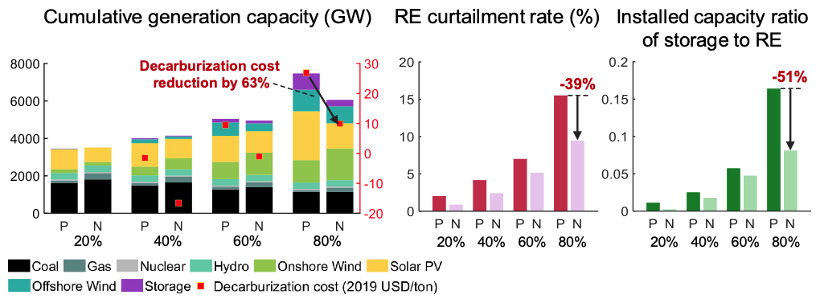

Figure 3
Benefits of Optimal Transmission for National vs. Provincial Power Balancing under 80% Decarbonization in 2050

Benefits of Power Storage, Green Hydrogen Production, and Slow Charging of Electric Vehicles

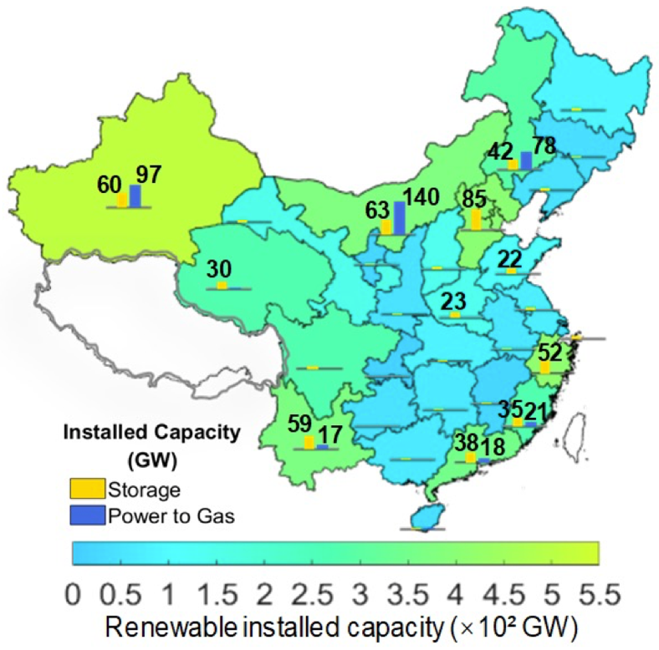

Figure 4
Geographical Distribution of Optimal Power Storage and Power-to-Gas (Green Hydrogen) Production Capacities under 80% Decarbonization in 2050

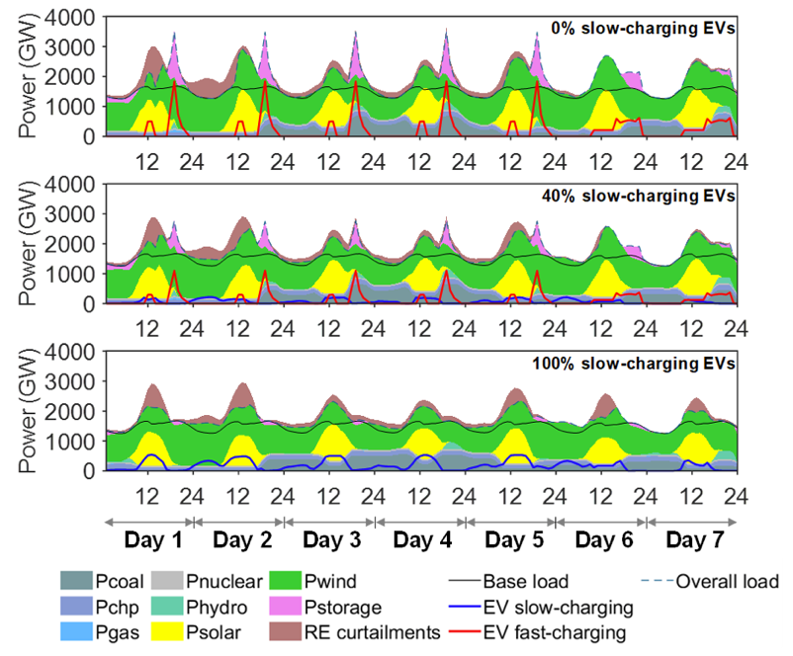

Figure 5
Hourly National Power Balances with a Fast- vs. Slow-Charging Electric Vehicle Fleet
under 80% Decarbonization in 2050

NOTES FOR DRAFTING

China's emissions on track to peak by mid-2020s: IEA
Kevin Foster, Argus Media
A new report from the International Energy Agency (IEA) has found that China’s existing policies put its CO2 emissions on track to peak by the mid-2020s, Argus Media reports. The outlet notes that China has the capacity to accelerate its transition to clean energy sources and reach carbon neutrality before 2060, according to the report. “China has the means and capabilities to accomplish an even faster clean energy transition that would result in greater social and economic benefits for the Chinese people and also increase the world’s chances of limiting the rise in global temperatures to 1.5C,” IEA’s executive director, Fatih Birol, is quoted saying. S&P Global also covers the IEA findings, reporting: “China needs to cut demand for coal by more than 80% by 2060, oil by around 60% and natural gas by more than 45% in order to realise its commitment of carbon neutrality by 2060, while renewables-based power generation, mainly wind and solar PV, needs to increase sevenfold between 2020 and 2060.”

Xinyu Chen, Yaxing Liu, Qin Wang, Jiajun Lv, Jinyu Wen, Xia Chen, Chongqing Kang, Shijie Cheng, and Michael B. McElroy, 2021, “Pathway towards Carbon-Neutral Electrical Systems in China by Mid-Century with Negative CO₂ Abatement Costs Informed by High Resolution Modeling,” Joule, X, X, pp. X-X. Available at [insert Joule webpage]
This assumes some remaining share of thermal power generation with carbon capture and storage.
Alternating current and direct current.
Chen et al., 2021, ibid.
Nuclear power is not renewable but because it does not emit CO₂ is often categorized with renewables.

